Open Source Stack

2.3.1 HAProxy
HAProxy is an open source software load balancer for both layer four and layer seven. Written in C and runing on top of Linux, HAProxy uses an event-driven model to reduce memory usage and gain high performance.[3] HAProxy also uses a single-buffering technique to reduce cost memory copy.

Illustration 1: HAProxy Logo
Although HAProxy is high performance, its design goal is to handle a large number of concurrent connections. It can only load balance traffic at the flow level and is unable to vertically divide a single elephant TCP flow into multiple mice flows.[4] HAProxy creates a session for each connection. A session consists of two TCP connections, one from the client to the load balancer and one from the load balancer to the server. The user needs to specify the load balancing policy in a config file before starting HAProxy.

2.3.2 Reasons for using MQTT over Websockets
- Connect directly web applications and things, so you can bootstrap a whole application with very little backend.
- Any other applications that don't want to use the 1883/8883 port and want to go over HTTP/HTTPS instead - this could be so that there is less of a chance of being blocked by a firewall, as most firewalls will let HTTP traffic through

2.4 Mosca MQTT broker

2.4.1 Mosca

Illustration 2: Mosca Logo
Mosca[5] sits between your system and the devices. It is open source and written in Javascript. Mosca is embeddable within any node application, allowing complete customization and the implementation of the pub-sub architecture.

2.4.1.1 Mosca Features
- MQTT 3.1 and 3.1.1 compliant.
- QoS 0 and QoS 1.
- Various storage options for QoS 1 offline packets, and subscriptions.
- Usable inside any other Node.js app.

2.5 Redis
Redis[8] is an open source, BSD licensed, advanced key-value cache and store. It is often referred to as a data structure server since keys can contain strings, hashes, lists, sets, sorted sets, bitmaps and hyperlogs.

Illustration 3: Redis Logo
Redis is a bit different from Kafka in terms of its storage and various functionalities. At its core, Redis is an in-memory data store that can be used as a high-performance database, a cache, and a message broker. It is perfect for real-time data processing.
Redis also has various clients written in several languages which can be used to write custom programs for the insertion and retrieval of data.[9] This is an advantage over Kafka since Kafka only has a Java client. The main similarity between the two is that they both provide a messaging service. But for the purpose of log aggregation, the various data structures of Redis do it more efficiently.

2.13 InfluxDB
InfluxDB is an open-source[26] time series database developed by InfluxData. It is written in Go and optimized for fast, high-availability storage and retrieval of time series data in fields such as operations monitoring, application metrics, Internet of Things sensor data, and real-time analytics.[28]

Illustration 4: InfluxDB Logo
InfluxDB has no external dependencies[27] and provides an SQL-like language with builtin time-centric functions for querying a data structure composed of measurements, series, and points. Each point consists of several key-value pairs called the fieldset and a timestamp. When grouped together by a set of key-value pairs called the tagset, these define a series. Finally, series are grouped together by a string identifier to form a measurement.
Values can be 64-bit integers, 64-bit floating points, strings, and booleans.
Points are indexed by their time and tagset.
Retention policies are defined on a measurement and control how data is downsampled and deleted.
Continuous Queries run periodically, storing results in a target measurement.[29]
Continuous queries are created when you issue a select statement with an into clause. Instead of returning the results immediately like a normal select query, InfluxDB will instead store this continuous query and run it periodically as data is collected. Only cluster and database admins are allowed to create continuous queries.[29]
Continuous queries let you precompute expensive queries into another time series in real-time.

Docker-compose

Directory structure
-Git-repo
- docker-compose.yml
- /haproxy
- Dockerfile
- haproxy.cfg
- /mosca
- /bin
- /public
- /lib
- Dockerfile
- index.js
- package.json
- /influxdb
- Dockerfile
- entrypoint.sh
- influxdb.conf
- /redis
- Dockerfile
- docker-entrypoint.sh

Docker-compose file
version: "2"
services:
haproxy:
build: ./haproxy
image: registry.ng.bluemix.net/tomspace2/haproxy-image1
container_name: ha_name
depends_on:
- mosca_srv1
ports:
- "80:80"
- "1883:1883"
networks:
- mynetwork
links:
- "mosca_srv1"
- "mosca_srv2"
environment:
BACKENDS: "mosca_srv1"
DNS_ENABLED: "true"
mosca_srv1:
build: ./mosca2
image: registry.ng.bluemix.net/tomspace2/mosca-image1
depends_on:
- redis
networks:
mynetwork:
aliases:
- mosca_srv1
links:
- "redis"
mosca_srv2:
image: registry.ng.bluemix.net/tomspace2/mosca-image1
depends_on:
- redis
networks:
mynetwork:
aliases:
- mosca_srv2
links:
- "redis"
influxdb:
build: ./influxdb
image: registry.ng.bluemix.net/tomspace2/influxdb-image1
networks:
mynetwork:
aliases:
- influxdb
redis:
build: ./redis
image: registry.ng.bluemix.net/tomspace2/redis-image1
networks:
mynetwork:
aliases:
- redis
networks:
mynetwork:

Docker-compose explanation
Docker compose is responsible for…

???

x.1 HAProxy

x.x.1 Dockerfile
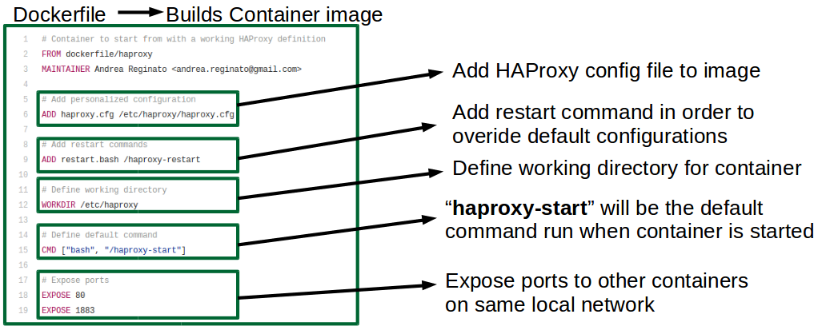
Illustration 5: HAProxy Dockerfile

x.x.2 haproxy.cfg
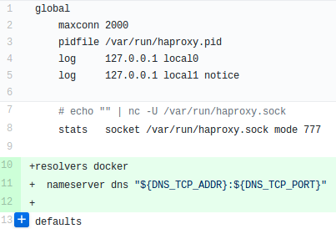

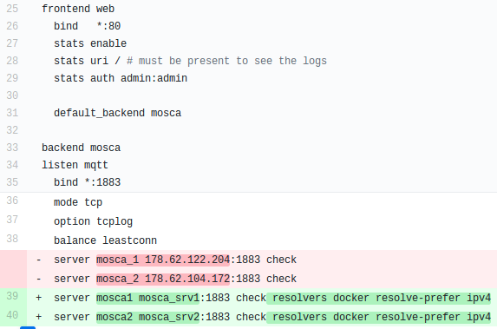

Configuration
Changes had to be made to the original haproxy.cfg file. The previous implementation used static IP addresses, DNS resoultion was implemented in order to enable developers to rebuild mosca containers without being required to update the haproxy.cfg file every time. This problem took a significant amount of time to solve as multiple issues with getting basic HAProxy functionality working first had to be solved.
The HAProxy container’s DNS entries are updated with the names and ip addresses of the two mosca containers. This is achieved through linking, which can be seen in the docker-compose file. This is necessary as the ip addresses of the mosca containers will be different each time they are recreated. Developers can now make small changes to the mosca container with very little build time as only one part of the system has to be rebuilt.

Above is the HAProxy config file for load balancing between 2 Mosca Brokers. The HAProxy listens for all requests coming to port 1883 and forwards them to the MQTT containers (mosca-srv1 and mosca-srv2) using the leastconn balance mode (selects the server with the least number of connections).

???

4.5.1 Problems Encountered
A common problem found with tutorials in relation to Docker is that the examples are quickly outdated. For example
FROM dockerfile/haproxy
needs to be changed to
FROM library/haproxy
After building a HAProxy container with the above Dockerfile. The command “docker logs <haproxy container id>” is run in order to determine if the build was successful. An error was reported in relation to the command
CMD [“bash”, “/haproxy-start”]
The error states that the “haproxy-start” cannot be found. A quick fix to remove this error was to change the line to
CMD [“bash”, “/haproxy-restart”]
This was done merely in a problem solving effort to remove the error to get the container to build.
Another problem encountered was attaching the “overide-config” file as a volume to the container. The process is as follows.
Build and run the container using the original haproxy image with the Dockerfile defined above.
docker pull library/haproxy
docker run -d -p 80:80 library/haproxy
Then issue the following command to the container once it is running.
docker run -d -p 1883:1883 -v <override-dir>:/haproxy-override dockerfile/haproxy
The HAProxy container accepts a configuration file as data volume option (-v), where <override-dir> is an absolute path of a directory that contains haproxy.cfg.
Other problems such as “cannot find user id for ‘haproxy’ ” had to be solved as well in order to remove errors when debugging with the “docker logs <haproxy container id>” command.

x.1 Mosca

x.x.1 Dockerfile
FROM mhart/alpine-node:4
MAINTAINER Matteo Collina <hello@matteocollina.com>
RUN mkdir -p /usr/src/app
WORKDIR /usr/src/app/
COPY ./ /usr/src/app/
RUN apk update && \
apk add make gcc g++ python git && \
npm install --unsafe-perm --production && \
apk del make gcc g++ python git
EXPOSE 80
EXPOSE 1883
ENTRYPOINT ["/usr/src/app/bin/server.js", "-d", "/db", "--http-port", "80", "--http-bundle", "-v"]

x.x.1 Configuration
- This Dockerfile builds the image for the Mosca container.
- The image is built on top of the base image mhart.alpine-node:4 found on Dockerhub.
- The directory /usr/src/app is created within the container and is set as the working directory.
- All files within the /mosca directory are then copied into the image.
- Dependencies are then installed followed by exposing the ports 80 and 1883. This should be expanded to open ports 8080 and 8883 once SSL/TLS functionality is introduced.
- The ENTRYPOINT configures the container to run as an executable.

x.x.2 Mosca Configuration
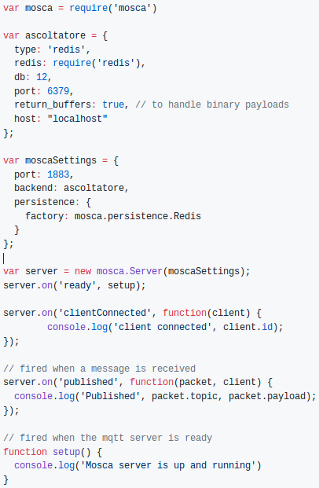
Illustration 6: Mosca Redis COnfiguration

Ascoltatore focuses on providing a simple and unique abstraction for all supported brokers, in this case Redis. The moscaSettings variable is configured to connect to the Redis server using Ascoltatore.
If using a non-standard redis port or redis is running on a different server, it is necessary to set the host and port in the persistence section.
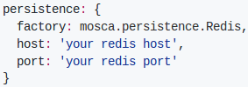
Illustration 7: Redis Persistence

4.1.2 Authentication and Authorization
With Mosca it is possible to authorize a client defining three methods.
- authenticate
- authorizePublish
- authorizeSubscribe

These methods can be used to restrict the accessible topics for specific clients. Below is an example of a client that sends a username and a password during the connection phase and where the username will be saved and used later on. (To verify if a specific client can publish or subscribe for the specific user).[x]
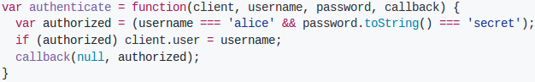
Illustration 8: Mosca Authenticate

The function “authenticate” accepts the connection if the username and password are valid.
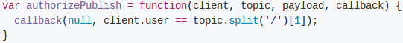
Illustration 9: Mosca Authorize Publish

In this case the client authorized as alice can publish to /users/alice taking the username from the topic and verifying it is the same as the authorized user.
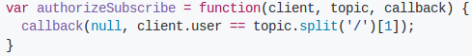
Illustration 10: Mosca Authorize Subscribe

In this case the client authorized as alice can subscribe to /users/alice taking the username from the topic and verifying it is the same of the authorized user.
With this logic someone that is authorized as 'alice' will not be able to publish to the topic users/bob.
This logic will be implemented in future to prevent car IoT devices publishing/subscribing to the “mobile-iotp” topic and similarly prevent mobile phone devices publishing/subscribing to the “car-iotp” topic. It is important to note that the code described in this section was not successfully implemented into the project.

x.1 Redis

x.x.1 Dockerfile
FROM alpine:3.6
RUN addgroup -S redis && adduser -S -G redis redis
RUN apk add --no-cache 'su-exec>=0.2'
ENV REDIS_VERSION 4.0.1
ENV REDIS_DOWNLOAD_URL http://download.redis.io/releases/redis-4.0.1.tar.gz
ENV REDIS_DOWNLOAD_SHA 2049cd6ae9167f258705081a6ef23bb80b7eff9ff3d0d7481e89510f27457591
RUN set -ex; \
apk add --no-cache --virtual .build-deps \
coreutils \
gcc \
linux-headers \
make \
musl-dev \
; \
wget -O redis.tar.gz "$REDIS_DOWNLOAD_URL"; \
echo "$REDIS_DOWNLOAD_SHA *redis.tar.gz" | sha256sum -c -; \
mkdir -p /usr/src/redis; \
tar -xzf redis.tar.gz -C /usr/src/redis --strip-components=1; \
rm redis.tar.gz; \
grep -q '^#define CONFIG_DEFAULT_PROTECTED_MODE 1$' /usr/src/redis/src/server.h; \
sed -ri 's!^(#define CONFIG_DEFAULT_PROTECTED_MODE) 1$!\1 0!' /usr/src/redis/src/server.h; \
grep -q '^#define CONFIG_DEFAULT_PROTECTED_MODE 0$' /usr/src/redis/src/server.h; \
make -C /usr/src/redis -j "$(nproc)"; \
make -C /usr/src/redis install; \
rm -r /usr/src/redis; \
apk del .build-deps
RUN mkdir /data && chown redis:redis /data
VOLUME /data
WORKDIR /data
COPY docker-entrypoint.sh /usr/local/bin/
ENTRYPOINT ["docker-entrypoint.sh"]
EXPOSE 6379
CMD ["redis-server"]

x.1 Influxdb

x.x.1 Dockerfile
FROM alpine:3.5
RUN echo 'hosts: files dns' >> /etc/nsswitch.conf
RUN apk add --no-cache tzdata
ENV INFLUXDB_VERSION 1.3.3
RUN set -ex && \
apk add --no-cache --virtual .build-deps wget gnupg tar ca-certificates && \
update-ca-certificates && \
for key in \
05CE15085FC09D18E99EFB22684A14CF2582E0C5 ; \
do \
gpg --keyserver ha.pool.sks-keyservers.net --recv-keys "$key" || \
gpg --keyserver pgp.mit.edu --recv-keys "$key" || \
gpg --keyserver keyserver.pgp.com --recv-keys "$key" ; \
done && \
wget -q https://dl.influxdata.com/influxdb/releases/influxdb-${INFLUXDB_VERSION}-static_linux_amd64.tar.gz.asc && \
wget -q https://dl.influxdata.com/influxdb/releases/influxdb-${INFLUXDB_VERSION}-static_linux_amd64.tar.gz && \
gpg --batch --verify influxdb-${INFLUXDB_VERSION}-static_linux_amd64.tar.gz.asc influxdb-${INFLUXDB_VERSION}-static_linux_amd64.tar.gz && \
mkdir -p /usr/src && \
tar -C /usr/src -xzf influxdb-${INFLUXDB_VERSION}-static_linux_amd64.tar.gz && \
rm -f /usr/src/influxdb-*/influxdb.conf && \
chmod +x /usr/src/influxdb-*/* && \
cp -a /usr/src/influxdb-*/* /usr/bin/ && \
rm -rf *.tar.gz* /usr/src /root/.gnupg && \
apk del .build-deps
COPY influxdb.conf /etc/influxdb/influxdb.conf
EXPOSE 8086
VOLUME /var/lib/influxdb
COPY entrypoint.sh /entrypoint.sh
ENTRYPOINT ["/entrypoint.sh"]
CMD ["influxd"]

Jenkins 2 about
Jenkins 2 brings Pipeline as code, a new setup experience and other UI improvements all while maintaining total backwards compatibility with existing Jenkins installations
Jenkins Pipeline is a suite of plugins which supports implementing and integrating continuous delivery pipelines into Jenkins. Pipeline provides an extensible set of tools for modeling simple-to-complex delivery pipelines "as code" via the Pipeline DSL. [x]
Jenkins is, fundamentally, an automation engine which supports a number of automation patterns. Pipeline adds a powerful set of automation tools onto Jenkins, supporting use cases that span from simple continuous integration to comprehensive continuous delivery pipelines. By modeling a series of related tasks, users can take advantage of the many features of Pipeline:
- Code: Pipelines are implemented in code and typically checked into source control, giving teams the ability to edit, review, and iterate upon their delivery pipeline.
- Durable: Pipelines can survive both planned and unplanned restarts of the Jenkins master.
- Pausable: Pipelines can optionally stop and wait for human input or approval before continuing the Pipeline run.
- Versatile: Pipelines support complex real-world continuous delivery requirements, including the ability to fork/join, loop, and perform work in parallel.
- Extensible: The Pipeline plugin supports custom extensions to its DSL [1] and multiple options for integration with other plugins.
The flowchart below is an example of one continuous delivery scenario easily modeled in Jenkins Pipeline:
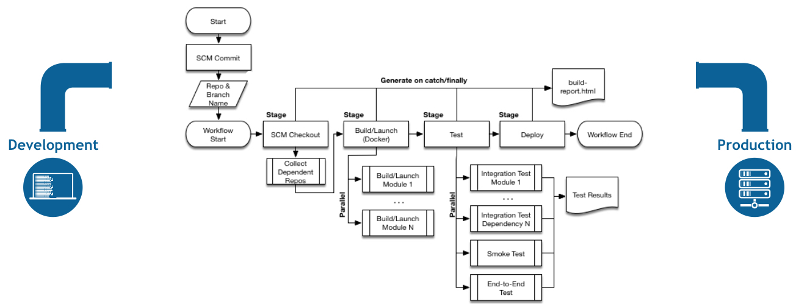

IBM Cloud DevOps plugin
With this Jenkins plugin, You can publish test results to DevOps Insights, add automated quality gates, and track your deployment risk. You can also send your Jenkins job notifications to other tools in your toolchain, such as Slack and PagerDuty. To help you figure out when code was deployed, the system can add deployment messages to your Git commits and your related Git or JIRA issues. You can also view your deployments on the Toolchain Connections page.
This plugin provides Post-Build Actions and CLIs to support this inteigration. DevOps Insights aggregates and analyzes the results from unit tests, functional tests, code-coverage tools, static security code scans and dynamic security code scans to determine whether your code meets predefined policies at gates in your deployment process. If your code does not meet or exceed a policy, the deployment is halted, preventing risky changes from being released. You can use DevOps Insights as a safety net for your continuous delivery environment, a way to implement and improve quality standards over time, and a data visualization tool to help you understand your project's health.

Environment variables
These environment variables and credentials are used by the IBM Cloud DevOps plugin to interact with DevOps Insights. Here is an example of setting them in the declarative pipeline format.
environment {
IBM_CLOUD_DEVOPS_CREDS = credentials('BM_CRED')
IBM_CLOUD_DEVOPS_ORG = 'dlatest'
IBM_CLOUD_DEVOPS_APP_NAME = 'Weather-App'
IBM_CLOUD_DEVOPS_TOOLCHAIN_ID = '1111111-aaaa-2222-bbbb-333333333'
IBM_CLOUD_DEVOPS_WEBHOOK_URL = 'https://jenkins:5a55555a-a555-5555-5555-a555aa55a555:55555555-5555-5555-5555-555555555555@devops-api.ng.bluemix.net/v1/toolint/messaging/webhook/publish' //Optional
}

Adding Cloud DevOps steps
The Cloud DevOps plugin adds four steps to Jenkins pipelines for you to use. These steps can be used in your pipelines to interact with DevOps Insights.
- publishBuildRecord, which publishes build information to DevOps Insights
- publishTestResult, which publishes test results to DevOps Insights
- publishDeployRecord, which publishes deployment records to DevOps Insights
- evaluateGate, which enforces DevOps Insights policies

Publishing build records
Publish build records with the publishBuildRecord step. This step requires four parameters. It can also accept one optional parameter.
gitBranch | The name of the Git Branch that the build uses.
gitCommit | The Git commit ID that the build uses.
gitRepo | The URL of the Git repository.
result | The result of the build stage. The value should be SUCCESS or FAIL.
buildNumber | Optional: The custom build number if you want to specify yourself

Jenkinsfile (Declarative Pipeline)
pipeline {
agent any
stages {
stage('Build') {
steps {
sh 'make'
}
}
stage('Test'){
steps {
sh 'make check'
junit 'reports/**/*.xml'
}
}
stage('Deploy') {
steps {
sh 'make publish'
}
}
}
}

agent indicates that Jenkins should allocate an executor and workspace for this part of the Pipeline.
stage describes a stage of this Pipeline.
steps describes the steps to be run in this stage
sh executes the given shell command

Jenkins master

Jenkins credentials
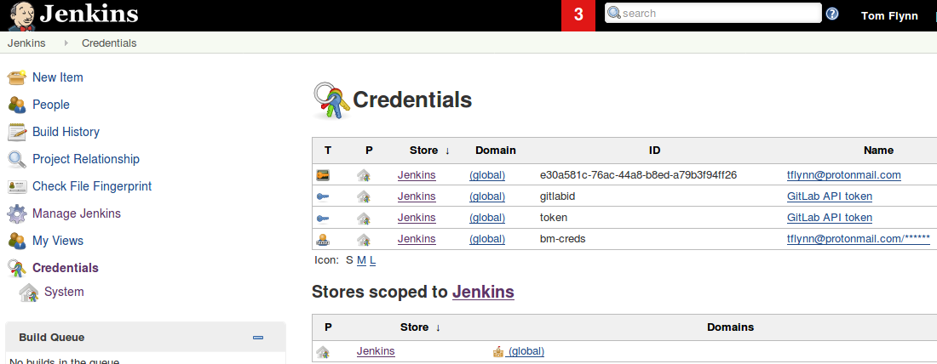

Jenkins pipeline configuration
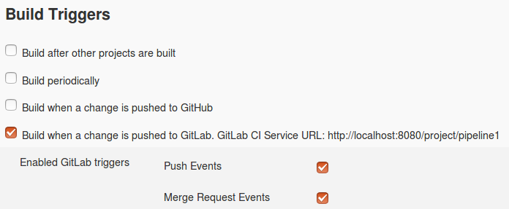

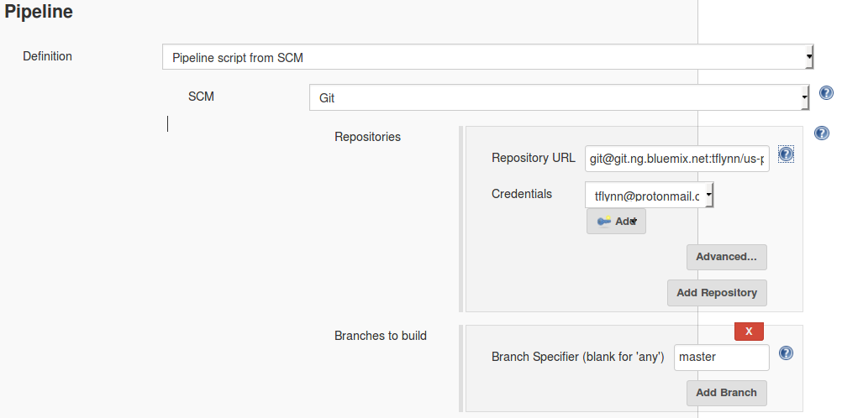

The pipeline is configured as “Pipeline script from SCM”. This definition is in the Jenkinsfile.

Jenkinsfile
pipeline {
agent any
environment {
IBM_CLOUD_DEVOPS_CREDS = credentials('bm-creds')
IBM_CLOUD_DEVOPS_ORG = 'tom1'
IBM_CLOUD_DEVOPS_APP_NAME = 'us-nodered-app'
IBM_CLOUD_DEVOPS_TOOLCHAIN_ID = '5a81013a-9b2d-4e17-a53b-1a908a213914'
IBM_CLOUD_DEVOPS_WEBHOOK_URL = 'https://jenkins:deb89eb9-8061-4db6-b43a-1a6eb8362b27:71020b52-212e-4184-b1c9-0f5072768803@devops-api.ng.bluemix.net/v1/toolint/messaging/webhook/publish'
}
stages {
stage('Build') {
environment {
GIT_COMMIT = sh(returnStdout: true, script: 'git rev-parse HEAD').trim()
GIT_BRANCH = 'master'
GIT_REPO = 'git@git.ng.bluemix.net:tflynn/us-pipeline-repo.git'
}
steps {
sh 'bx api https://api.ng.bluemix.net'
sh 'bx login -u $IBM_CLOUD_DEVOPS_CREDS_USR -p $IBM_CLOUD_DEVOPS_CREDS_PSW -o $IBM_CLOUD_DEVOPS_ORG -s space-us'
sh '''
sudo bx ic init
sudo bx cr login
docker-compose build
'''
}
post {
success {
publishBuildRecord gitBranch: "${GIT_BRANCH}", gitCommit: "${GIT_COMMIT}", gitRepo: "${GIT_REPO}", result:"SUCCESS"
}
failure {
publishBuildRecord gitBranch: "${GIT_BRANCH}", gitCommit: "${GIT_COMMIT}", gitRepo: "${GIT_REPO}", result:"FAIL"
}
}#end post
}#end Build stage

stage('testing') {
steps {
echo 'Performing integration tests....'
}
post {
success {
echo 'integration passed all tests'
}
failure {
echo 'integration failed to pass all tests'
}
}#end post
}#end test stage

stage('Deploy') {
steps {
sh ‘COMPOSE_HTTP_TIMEOUT=200 docker-compose -p projectName up’
sh ‘bx ic ip-bind 169.46.159.224 ha_name’
}
}#end deploy stage
}#end pipeline

Pipeline explanation

???

X Mosca Implementation and testing


4.2.1 IBM Container Service Login
Illustration 11: Bluemix Logo
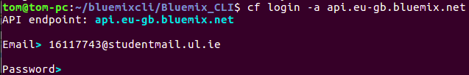
Illustration 12: Container Service Login

4.2.2 Setting Namespace and Authentication with IBM Container’s Registry
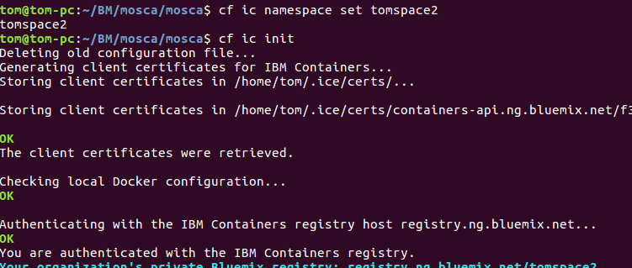
Illustration 13: Setting Namespace

4.2.3 Bluemix Dashboard
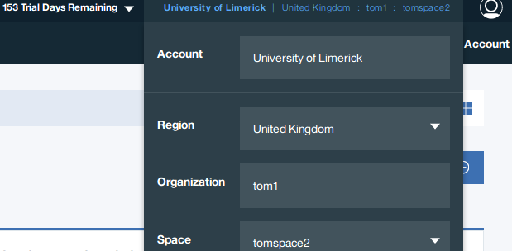
Illustration 14: Bluemix Dashboard

4.2.4 Cloning Mosca Repository From Github
Illustration 15: Cloning Mosca Repository

4.2.5 Pushing Mosca Image to the “tomspace2” Registry
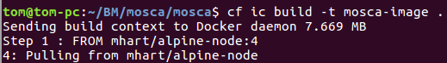
Illustration 16: Pushing Mosca Image

4.3 Mosca Broker Container
The Mosca image was pushed to the Bluemix image registry after testing the functionality of the Mosca Broker on the local Ubuntu machine. The test consisted of using the Mosquitto service installed on the local machine. Mosquitto verified the Mosca Broker’s functionality by publishing and subscribing in different terminals.
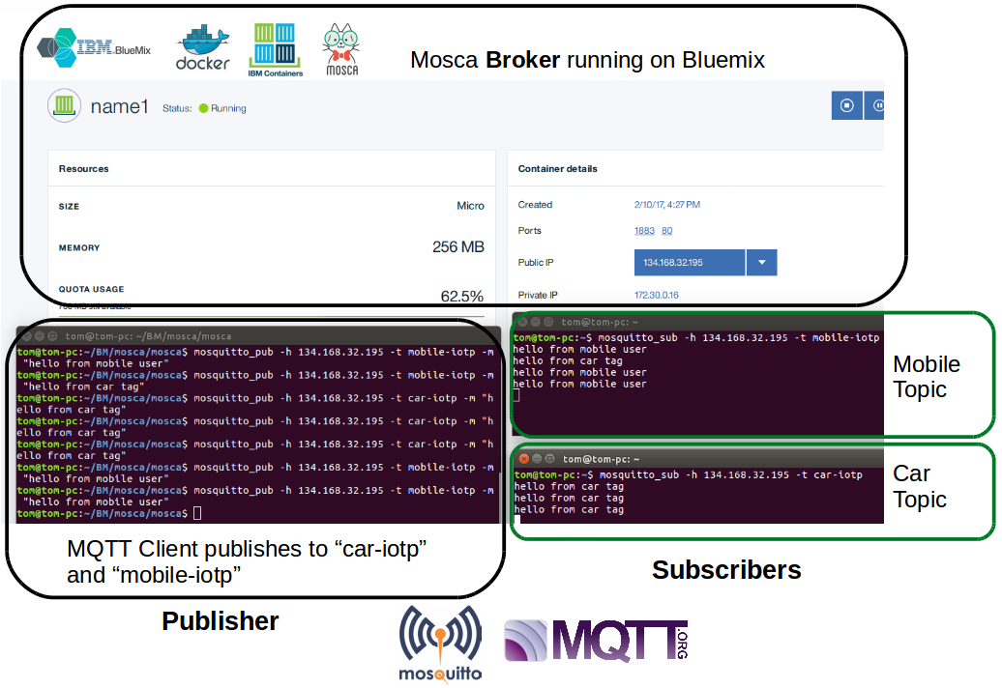
Illustration 17: Mosca Broker Test

4.3.1 Broker
The top half of the above figure shows the Bluemix Dashboard. It displays the Mosca Broker running in a Container called “name1”. It has the ports 80 and 1883 exposed.

4.3.2 Mosquitto
The terminal on the left is using Mosquito to publish to the topics “mobile-iotp” and “car-iotp”. These messages are being sent to the Mosca Broker Container running on Bluemix.
The terminals on the right are using Mosquito to subscribe to the mobile-iotp and car-iotp topics.

HAProxy testing

Testing
A Node-RED flow was configured to inject MQTT messages periodically to the public IP of the HAProxy container. To confirm that the HAProxy was functioning, a second Node-RED flow was used to subscribe to the publishing topic and IP address of the HAProxy container. Despite the fact that the messages are being divided between the two separate containers, all message were received by the subscribing Node-RED flow.
This test is sufficient for confirming basic functionality but a more detailed approach is needed to measure all the various metrics involved such as Quality of service, load balancing method (least connection, round robin) and message frequency. These tests require knowledge of the exact number of messages sent vs received, by comparing these two metrics we can gain valuable insight from various configurations of the HAProxy.

HAProxy before test
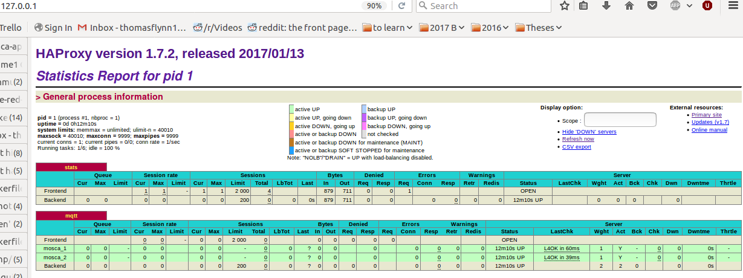

HAProxy after test
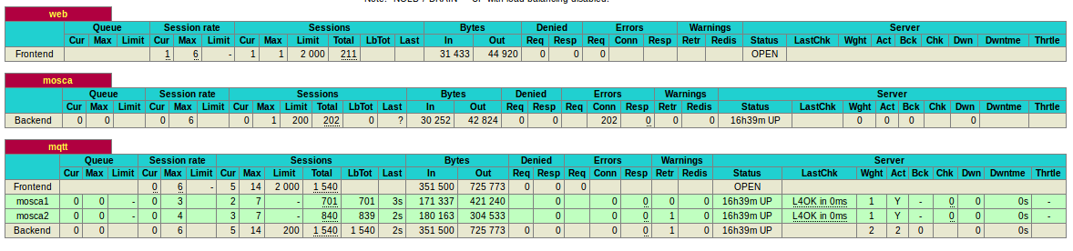

Bluemix image registry
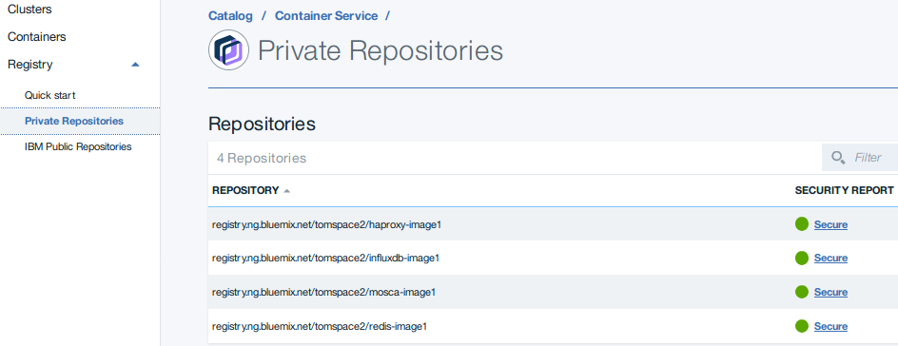

T1
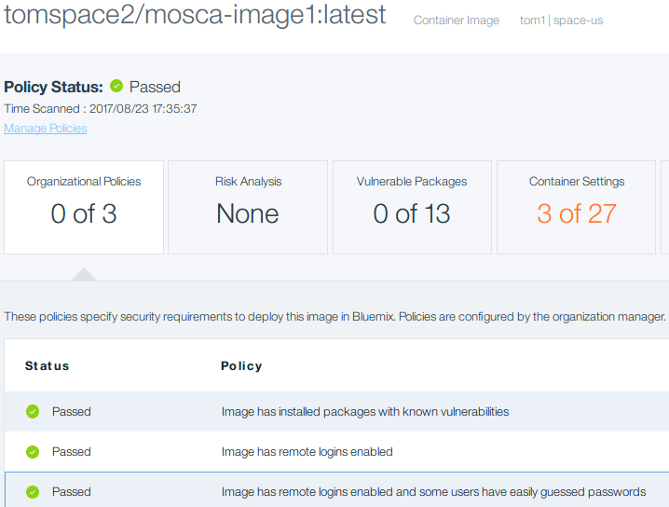

T3
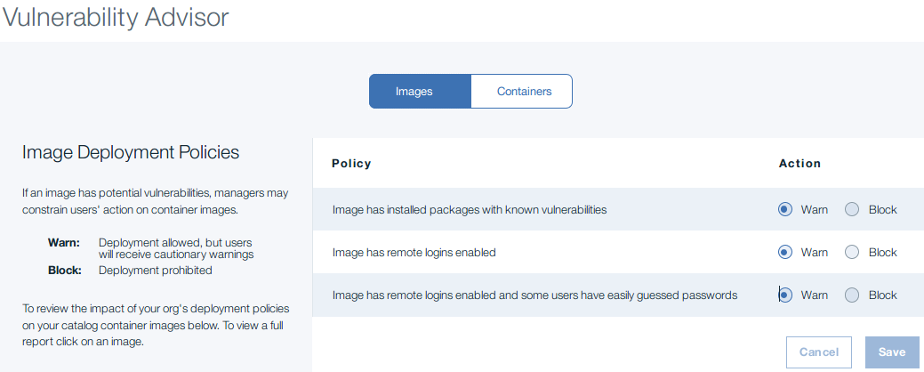

T4
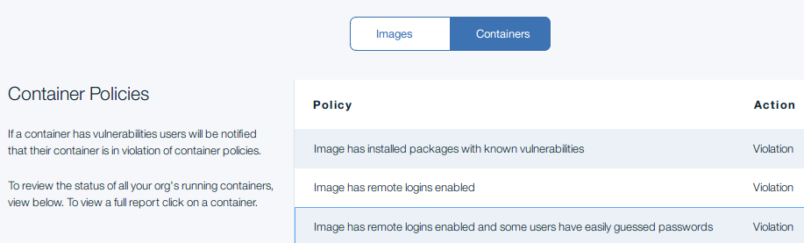

Logging and monitoring

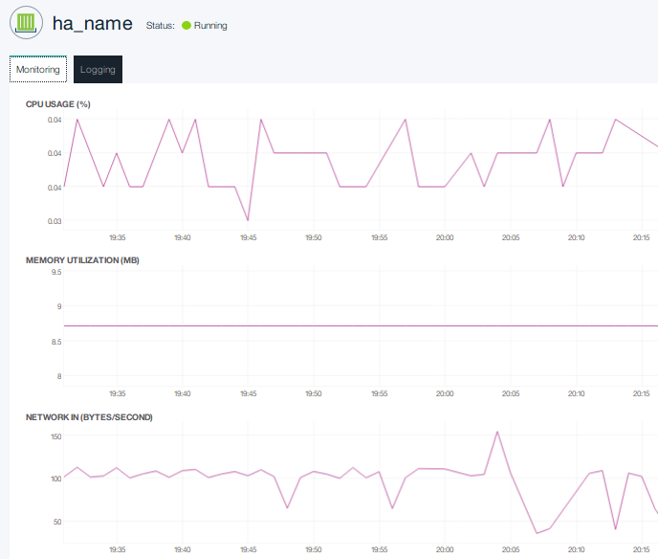

4.6 Node-Red

4.6.1 Primary Flow
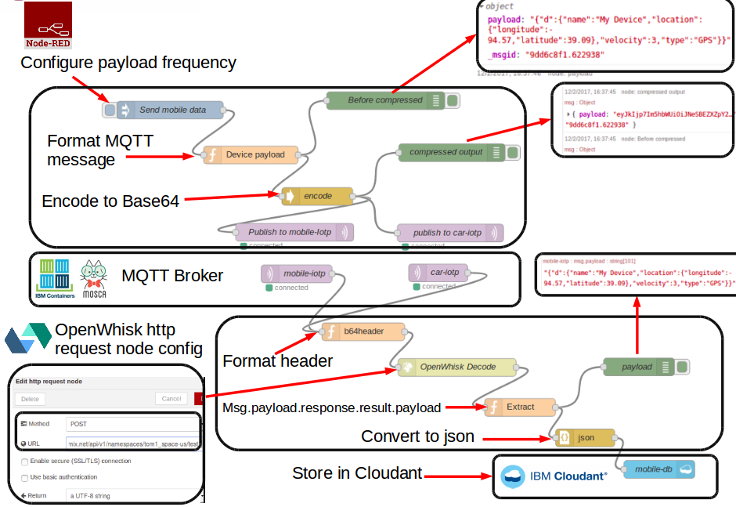
Illustration 18: Primary Flow
This flow represents the the core application functionality of the theses. Data is flowing from the simulated IoT gateway to the Mosca broker hosted on Bluemix. The data is then decoded using OpenWhisk and stored as JSON in the Cloudant database.

4.6.2 Test Cloudant Flow
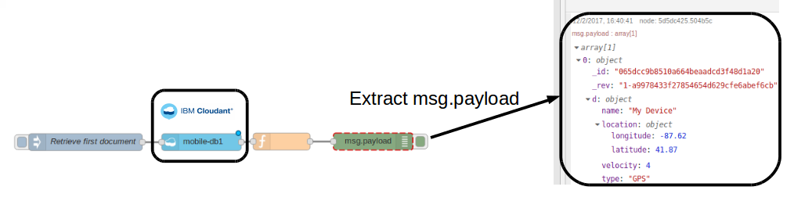
Illustration 19: Test Cloudant Flow
The above flow verifies that data has reached the Cloudant database in JSON format.

4.7 OpenWhisk

4.7.1 Base64 Decode Action Configuration
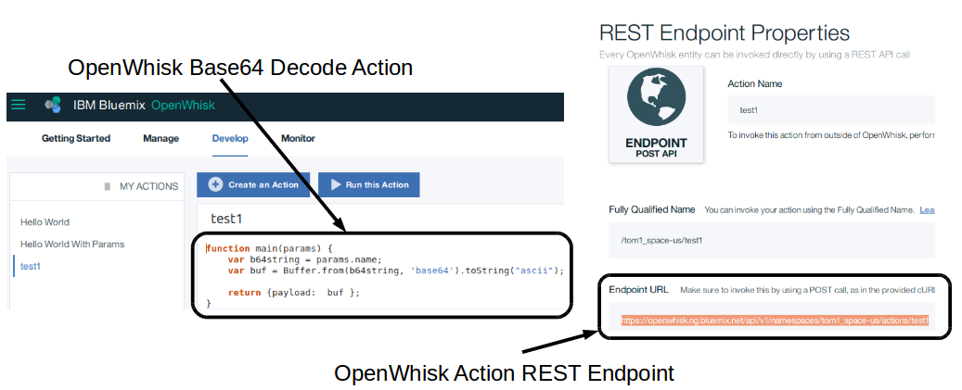
Illustration 20: OpenWhisk Decode Action

4.7.2 Node-RED http post configuration
Node-RED has an OpenWhisk node available that makes it straightforward to call actions, however invoking the action through the http request node was done as a quick fix for the problems encountered using the OpenWhisk node.
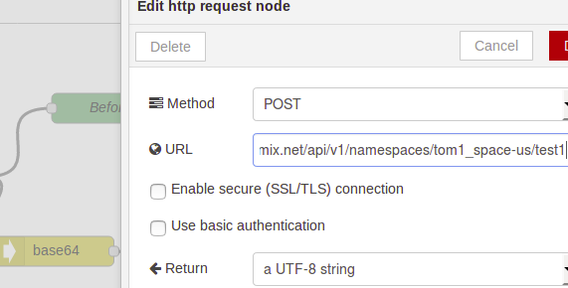
Illustration 21: Http Request Node

